26S6 Homework
Word Relationships and Statistics

What will homework look like?
Every week, we will give you 6–8 questions to work on (about 30 minutes), split between English language arts and mathematics. Some questions will be more challenging than others.

Try your best to submit your work before the start of the next lesson, but remember that homework is optional. You will sometimes see additional practice worksheets. You do not need to complete those; we will only grade the documents labeled “26SX Homework.”

Homework will be graded out of eight points; your assigned tutor will give you feedback on your work. Feel free to resubmit and correct your mistakes as many times as needed.

English Language Arts: Word Relationships
Read 🅐 Excerpt from “The Shinansha” and answer questions 1-4.

- In paragraph 3, how does the phrase “of the Mythological age” affect the tone of the excerpt? [1]
- It establishes the excerpt’s factual tone, which matches the fact that events from recorded history are recounted.
- It highlights the excerpt’s comedic tone, which highlights that magical events are presented as historical fact.
- It illustrates the excerpt’s heroic tone about events that took place before China had any emperors.
- It establishes the excerpt’s epic tone, which suggests to the reader that events are set in an era of heroes and magic.

- The author most likely used the phrase “strange to relate” (paragraph 4) to show that [1]
- the event he is about to describe is difficult to put into words.
- the event he is about to describe was hard for Kotei’s mother to understand.
- the event he is about to describe is surprising and curious.
- the event Kotei’s mother witnessed was unimportant.

- The author most likely includes the detail about Kotei’s mother’s vision (paragraph 3) to [1]
- explain how Kotei learned to invent things
- suggest that Kotei’s greatness was foretold
- show that visions were common in that time period
- prove that the story is historically accurate

- Read this sentence from paragraph 1.
The compass, with its needle always pointing to the North, is quite a common thing, and no one thinks that it is remarkable now, though when it was first invented it must have been a wonder.
How does the author’s use of the words “common” and “remarkable” affect the reader’s understanding? [1]
- It shows that the compass is no longer useful in modern times.
- It suggests that the compass was never truly important.
- It implies that modern inventions are more impressive than older ones.
- It contrasts present familiarity with past amazement to emphasize changing perceptions.

Mathematics: Statistics
Clearly indicate the necessary steps, including appropriate formula substitutions, diagrams, graphs, charts, etc. You may not use a calculator. For all questions in this part, a correct numerical answer with no work shown will receive only 0.5 points.

- As a cashier, you are required to tally how many customers you serve each day. On some days, you may serve 100 people a day; on a very busy day, you may serve hundreds. You will then graph the number of customers per day over a longer period of time.

You want a graph that shows the shape of the data, and that best answers the question, "About how many customers can I expect in a day?" What type of graph is best for this scenario? Justify your answer. [1]
Justify your answer here.

- Your boss, Jericho, records how many of his 10 employees show up to work at his restaurant, Jericho's Burgers, each day (at any time) for 20 days.

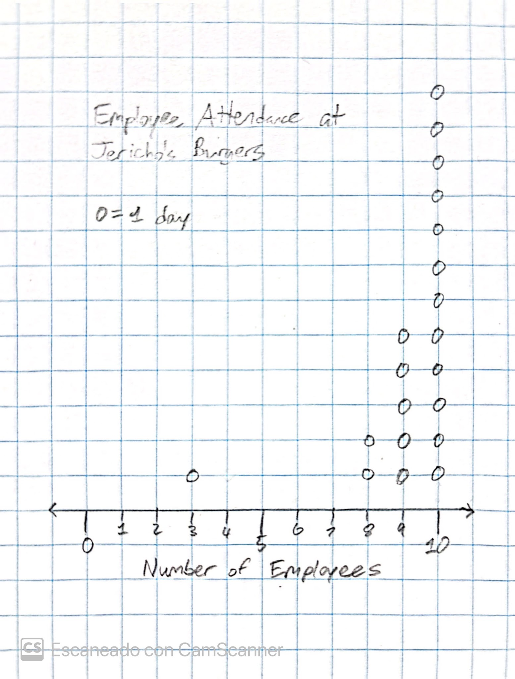

Identify what the arithmetic mean, median, mean absolute deviation (MAD), and interquartile range (IQR) measure in this data. [2]
Write your answer here.

- Some Stuyvesant High School students frequently visit the McDonald's a block away. Recently, the school newspaper surveyed the amount of money students typically pay at McDonald's. The following data represents the amount of money spent at McDonald's over the past week by 12 students, rounded to the nearest dollar.

10, 0, 6, 5, 5, 0, 0, 9, 3, 0, 10, 0

Which of the following dot plots best represents this data? [1]
- 
 